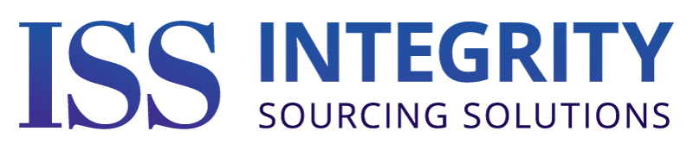
"ISS has multiple resources for each service we provide. Rather than offering just one solution, we assist our customers in selecting the best resource to fit their individual project's needs”
Business Development | Exit Planning, M&A, Market Research, Private Funding Sourcing, Strategic Planning For Business Development & Marketing, Supply Chain Sourcing
Cable & Wire Harnesses | Custom Molded Cables, DC/Flat Ribbon Cables, Harness Assemblies, Over Molding, Quick Terminations, VMI Services
Contract Manufacturing | Box Build, Conformal Coating, Electromechanical Assembly, Kitted & Turnkey, ODM, Potting, SMT & Through Hole PCB Assembly
Engineering Services | Artificial Intelligence (AI), ASIC, Bare Metal Firmware, Board Support Package Development, Cyber Security, Embedded Device Security, Embedded Software & BSP, Firmware, FPGA, Hardware Engineering, Internet Of Things (IoT), PCB Design & Layout, Total Project Management
Engineering Staffing | Contract Engineers, Engineering Teams, Permanent Engineers For All Engineering Disciplines
Metal Fabrication | 3D Printing, Assembly, CNC Machining, Laser Cutting, Painting & Powder Coating, Sheet Metal Fabrication, Tool & Die Making, Tube Bending, Water Jet Cutting, Welding
PCB Assembly | Conformal Coating, Flex Circuitry, Kitted & Turnkey PCB Assembly, Multilayer, Production, Prototyping, Single & Double-sided, PCB Design & Layout Services Available
Plastic Fabrication | 3D Printing, Injection Molding, Mold Design & Fabrication, Rubber Molding, Silicone & Urethane Casting, Thermoforming
Quality & Regulatory  Consulting | AS9100D, CE, CMMC, CSA, ISO9100:2015, ISO13485, TÜV, UL, VDE

For More Information, Please Contact:
Greg Bishop at gregb@integritysourcingsolutions.com or 503.484.4706
Mark Norton at markn@integritysourcingsolutions.com or 509.954.8781
Or Visit Us At:
IntegritySourcingSolutions.com

